Project Design Phase-I - Solution Fit 

**Project Title: AI-based localization and classiﬁcation of skin disease with erythema Team ID:** PNT2022TMID37911

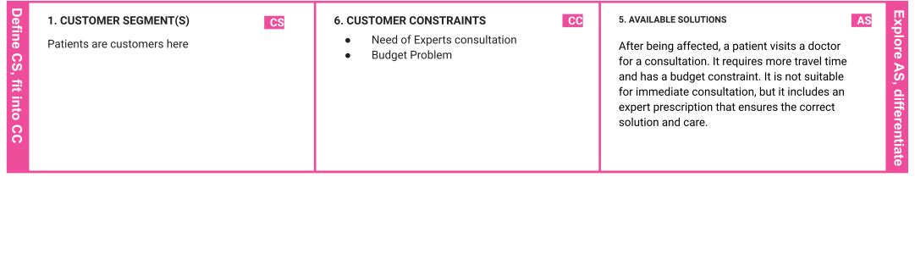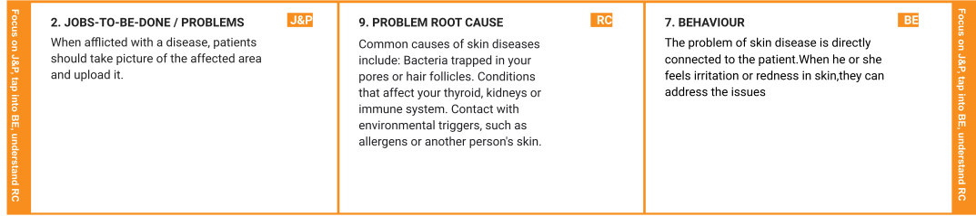

|  |  |  |  |  |  |  |
| --- | --- | --- | --- | --- | --- | --- |
|  | **3. TRIGGERS**  Patients can know about this from their neighbours, colleagues, and friends. | **TR** | **10. YOUR SOLUTION SL**  To overcome the problem we are building a model which is used for the prevention and early detection of skin cancer, psoriasis. Basically, skin disease diagnosis depends on the different characteristics like colour, shape, texture etc.  Here the person can capture the images of skin and then the image will be sent the trained model. The model analyses the image and detect whether the person is having skin disease or not | 1. **CHANNELS of BEHAVIOUR**    1. **ONLINE**   Users upload pictures of the affected area. | **CH** |  |
|  |  | **8.2 OFFLINE** |  |
|  |  | After the classiﬁcation of disease , they can  consult a doctor and cure the disease. |  |
| **4. EMOTIONS: BEFORE / AFTER EM** | |
| Before: The patient may experience discomfort, insecurity, and mental fear after being infected. | |  |  |
| After: They can know about the affected disease. | |  |  |